**Project Plan**

**EKG Using Cloud Services**

**Submitted by Team 3:**

**Bhargav Bobba**

**Jennifer Cox**

**Surya Indukuri**

**Promyse Ward**

**Revision History**

| **Name** | **Date** | **Reason For Changes** | **Version** |
| --- | --- | --- | --- |
| Project Plan | 9/30/2021 | First Draft | 1.0 |

**A. Introduction**

An electrocardiogram (ECG or EKG) is a common test used in doctor’s offices or hospitals to detect cardiac problems and/or monitor heart health. Traditionally, a nurse or technician will attach up to 12 electrode sensors to the patient. These electrodes are attached with wires to an EKG machine which displays the electrical activity on a monitor or prints the results on paper. This requires the nurse to wait in the patient room while the test is being done, during which time she is not able to perform other duties.

The goal of this project is to design an EKG system that can use wifi to upload the EKG data to a cloud backend which in turn allows the data to be viewed by medical personnel or the patient via a web-based user interface. This will improve the administration of EKGs in a hospital setting by allowing a nurse to monitor multiple patients’ EKG data from a central location.

The purpose of this document is to provide information about EKG Using Cloud Services project. It includes deliverables, schedules, risks, dependencies, assumptions, estimates, project team, and change management.

**B. Software Project Description**

This project will be an EKG system with a cloud backend and a web-based UI. The traditional 12 electrode sensors will be placed on the patient and attached to an EKG machine. The EKG machine will use wifi to upload the patient EKG data to the cloud backend where analytics can be used to identify subsets or points of interest in the data. The data can then be accessed via a web-based user interface. Nurses will be able to view this data through the interface in real-time with graphics displaying important metrics.

With this system, there will be three main users: Patient, Doctor/Nurse, and Administrator. Patients will have access to view their medical records. Doctors and nurses will be able to view their patients’ medical records. Administrators will be able to register patients and modify medical records for patients.

**C. Team Members**

The roles and responsibilities of each team member are as follows:

Promyse Ward - Project Manager

* Lead and manage the project team
* Assign tasks to project team members
* Keep track of project progress

Jennifer Cox - System Analyst

* Gather and document requirements from client/users
* Verify that deliverables meet requirements

Bhargav Bobba - Quality Assurance Manager

* Convert requirements and design documents into test cases to develop test plan

Surya Indukuri - Test Analyst

* Gather and manage test data
* Document and evaluate test outcomes

**D. Deliverables**

The deliverables for this project include:

* Project plan (this document)
* Requirements document
* Design document
* Test plan
* Final project demo/presentation

**E. Project Timeline**

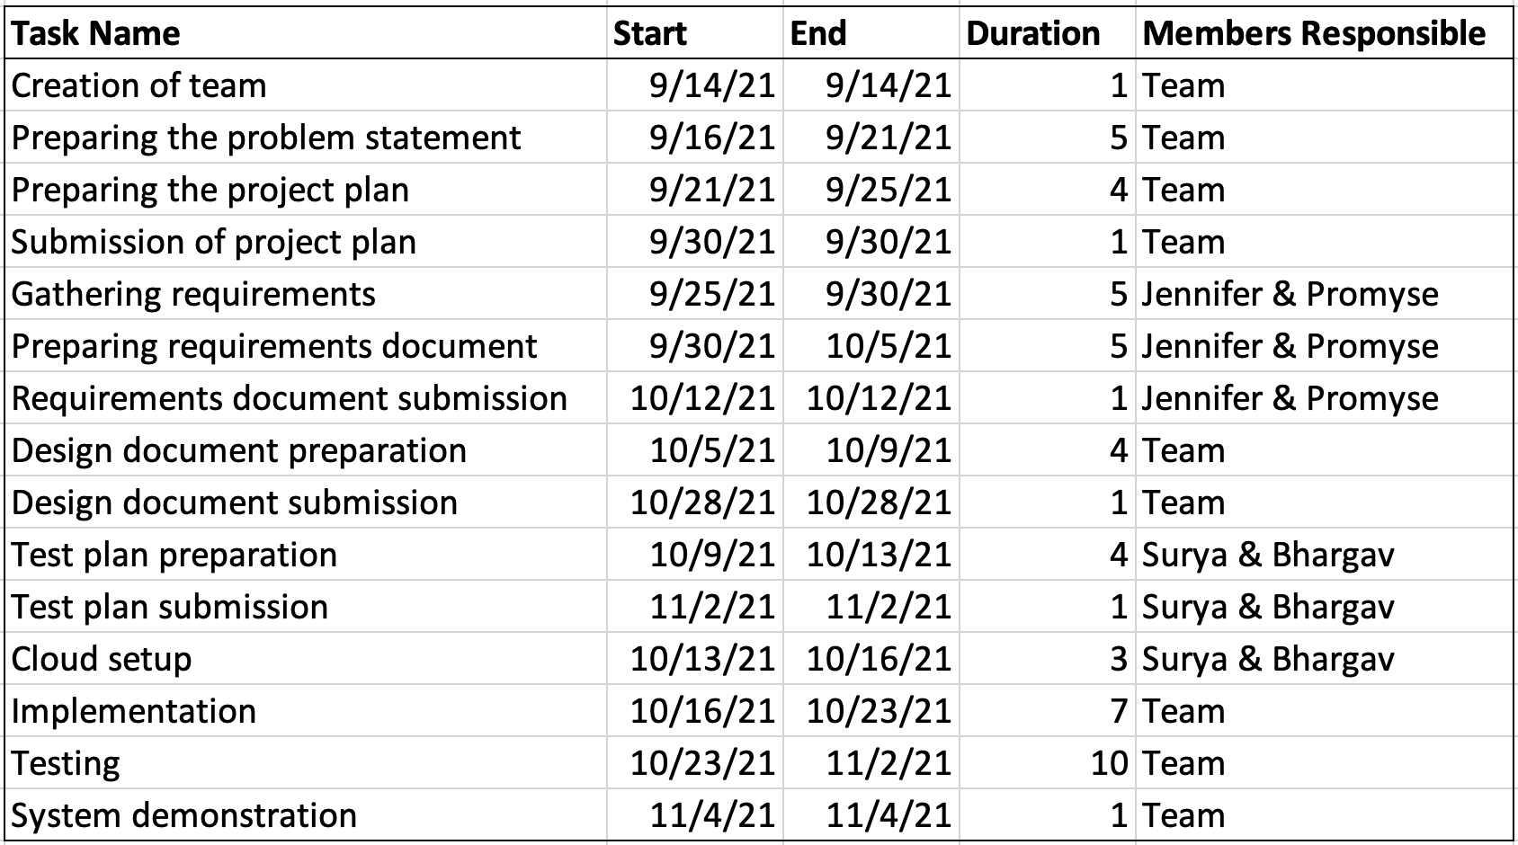

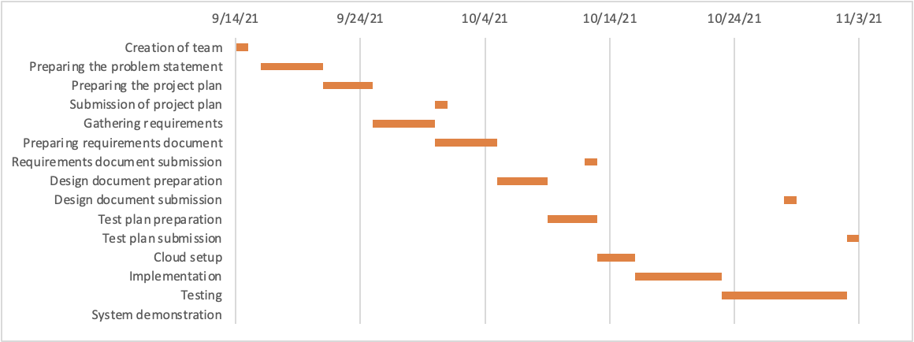

**Responsibility Assignments:**

The Gantt chart contains all task assignments.

**F. Potential Difficulties**

There are three major parts in this software project which includes Data Collection, Data Processing and Data visualization. Potential difficulties with each part are as follows:

**Data Collection:**

One potential issue with data collection is the integration of heterogeneous sources. Healthcare data is diverse and comes from many different sources such as insurance companies, notes from doctors, images from scans, and even wearable health monitoring devices. These various data types and sources may follow different standards that makes the integration of data into a central database difficult. Another issue with data collection is adhering to HIPAA standards for protecting the privacy of personal health information and ensuring patients have access to their health information.

**Data Processing:**

The potential issues with data processing are primarily a result of the large amounts of data generated by continuous EKG monitoring. One concern is a potential time delay in processing this complex data that could reduce the quality of patient care. Another potential difficulty is ensuring data quality and identifying relevant subsets of data. With continuous EKG monitoring, doctors are usually interested only in subsets of the data where cardiac events are occurring. It is important to identify the relevant data to get reliable insights for making health related decisions.

**Data Visualization:**

There are two main potential difficulties with visualization of these potentially very large EKG datasets. First, the dataset must be prepared for visualization, and traditional dataset manipulation methods could fail due to lack of temporary storage or memory. The second problem is how to present the data as visual media. The lengthy time-series data could be difficult to visualize in a way that is useful to medical professionals for decision making. While the nurse needs to be able to monitor the data in real time, the doctor may only be interested in small sections of the larger dataset.

**G. Resources**

Human resources:

Project Team:

* Promyse Ward - Project Manager
* Jennifer Cox - System Analyst
* Bhargav Bobba - Quality Assurance Manager
* Surya Indukuri - Test Analyst

Outsourcing:

* Programmer
* Cloud Engineer
* Web Developer

Hardware:

* EKG Machine

AWS Cloud Services:

* S3 simple storage
* Relational Database Service (RDS)
* Lambda
* EC2 Instance

**References:**

Mayo Clinic, ‘Electrocardiogram (ECG or EKG)’,

<https://www.mayoclinic.org/tests-procedures/ekg/about/pac-20384983>

Amazon Web Services

<https://aws.amazon.com/>

Health and Human Services, ‘Summary of the HIPAA Privacy Rule’,

<https://www.hhs.gov/hipaa/for-professionals/privacy/laws-regulations/index.html>